Service for the Lord’s Day
August 18, 2019

Eastminster
Presbyterian
Church

ORDER OF WORSHIP FOR THE LORD'S DAY
August 18, 2019 10:00 a.m.

* Congregation is invited to rise in body or in spirit.
Bold text is read or sung by the congregation.

GATHERING

Welcome and Announcements (Please sign the friendship pads)
The grace of our Lord Jesus Christ be with you all.
And also with you.

Prelude

Call to Worship
Friends, if you lift your net and it is empty,
Come here!
We’ll cast it out again into Christ’s abundance.
If you open your eyes but do not recognize the Holy One,
Come here!
We’ll find the Risen Christ here among us.
If your life is filled with mourning,
Come here!
Christ is leading a dance of joy.
Come here, sisters and brothers
to give blessing and honor and glory to God!

*Hymn #267 Come, Christians, Join to Sing
*Call to Confession

*Prayer of Confession
Wondrous God, we confess that at times our doubts and fears override our hope and faith. When things are not perfect in our eyes, we murmur and complain. We lose hope in the people around us and we lose hope in you. Forgive us when we lose sight of the joy of your love and instead fall into despair. Forgive our loss of hope. Let your healing, life-giving waters pour over us.
(Silent prayers of confession)

*Declaration of God’s Grace

*Congregational Response [#582 Glory to God]
*Sharing the Peace of Christ
(Turn to your neighbors and say, “The Peace of Christ be with you.”)

PROCLAMATION OF THE WORD

Children’s Story Butterflies Under Our Hats
by Sandy Eisenberg Sasso

Special Music Jadrian Tarver

Prayer for Illumination

Reading from Scripture
John 21:1-19 (Pew Bible, pages 109-110 - NT)

Sermon

RESPONSE TO THE WORD

Hymn #250 In the Bulb There Is a Flower

Offering of Resources and Prayer
Financial offerings support the life and mission of Eastminster Presbyterian. If you have prayers to be shared during our prayers of the people, please place them in the offering plates.
Offertory
Doxology[#606 Old Hundredth]
Praise God, from whom all blessings flow;
Praise God all creatures here below;
Praise God above, ye heavenly host;
Praise Father, Son, and Holy Ghost. Amen.
*Prayer of Dedication

Joys and Concerns of the Congregation / Prayers of Intercession / The Lord’s Prayer
Our Father who art in heaven, hallowed be thy name. Thy kingdom come, thy will be done, on earth as it is in heaven. Give us this day our daily bread; and forgive us our debts, as we forgive our debtors; and lead us not into temptation but deliver us from evil. For thine is the kingdom and the power and the glory, forever. Amen.

* Hymn #39 Great is Thy Faithfulness

*Charge & Benediction

*Benediction Response #765 May the God of Hope Go With Us
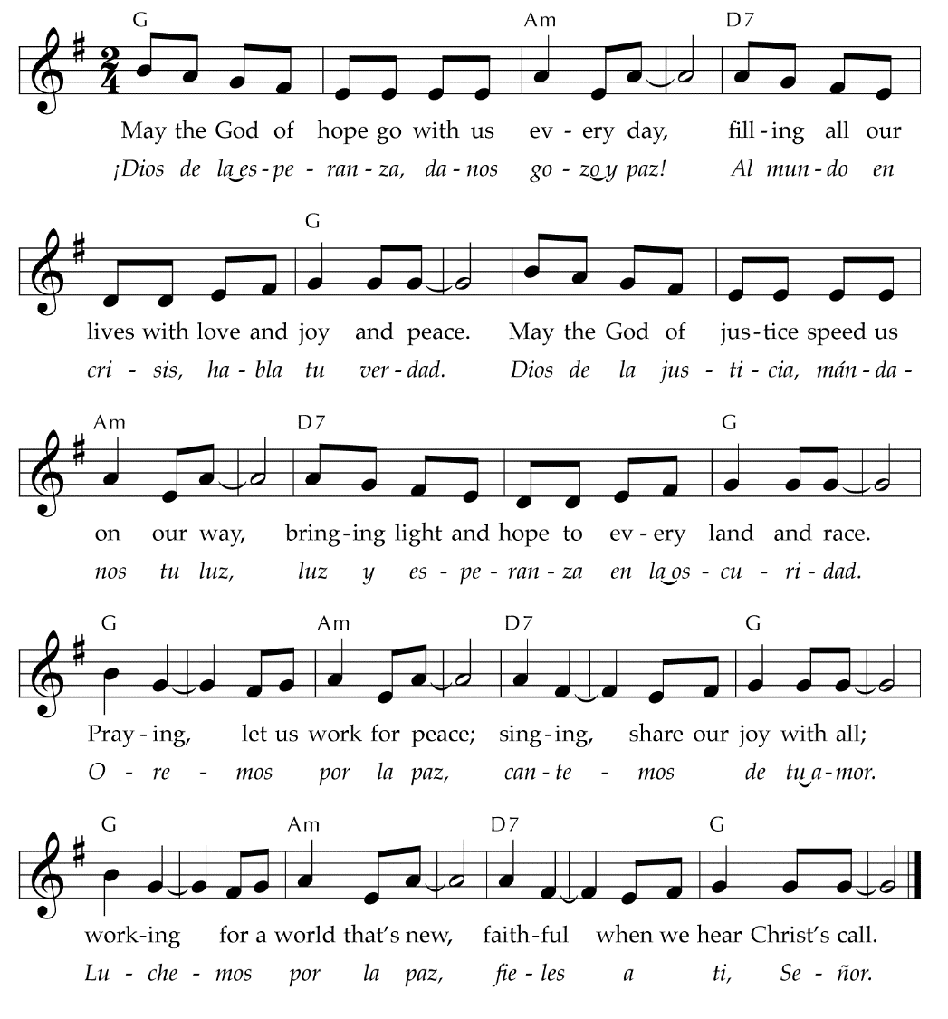
*Postlude

Participants in today’s service:
Minister: Rev. Kristin Stroble
Worship Leader: Elder Mary Harvey
Children’s Message: Sue Rosser
Organist: Tamar Mikeladze

New Here? Thank you for joining us as we worship God this morning. Information about our church is available in the narthex, including our weekly email. We invite you to sign in on the Friendship pads found at the end of the pew, so we can greet you by name. Please join us for Coffee Fellowship after worship, in the space we call the Green Room, which is to the west of the sanctuary.

Prayer Cards are in the Friendship Pads, which are at the end of each pew. If you have a prayer request that you would like announced during the service, please write it on the prayer card and you can place it in the plate during the collection of the offering. The Pastor will read them (unless marked private) before the Pastoral Prayer.

Children and Worship: Children are always welcome in worship at Eastminster. Children's bulletins can be found outside the sanctuary doors as well as activity bags, which they can use during the service. We have created a space for children at the front of the sanctuary. Your child is welcome to use that space or remain in the pews with you.

Today at Eastminster
Ushers
Head Usher: Heather Heitman; Sulin Campbell, Sam O’Neill
Greeters
Elaine and Allen Cable and Chase and Sue Hunt
Flowers
The flowers today are given by Dave and MaryAnn Merchant in honor of their 63rd wedding anniversary.
Church Leadership and Staff
Rev. Kristin Stroble Pastor
Dr. Fred Graham Parish Advisor
Rev. Shirley Paxton Parish Advisor
Neil Myer Director of Christian Education
Bridgette Redman Office Administrator
Jadrian Tarver Choir Director
Tamar Mikeladze Organist
Heather Myer Bell Choir Director
Laurin Schulz Nursery Attendant
This Week at Eastminster
August 18- August 25
TODAY, 8/18
Worship 10:00 a.m.
Fellowship 11:00 a.m.
Officer Training 11:15 a.m.
MONDAY, 8/19
Full Staff Meeting 9:30 a.m.
TUESDAY, 8/20
Officer Training 5:00 p.m.
UKirk Board 6:30 p.m.
20s and 30s 7:00 p.m.
WEDNESDAY, 8/21
Trivia at Reno’s East 8:00 p.m.
THURSDAY, 8/22
Cultured Purls 9:00 a.m.
SUNDAY, 8/25 Backpack Sunday
Worship 10:00 a.m.
Fellowship 11:00 a.m.

AA: Wed. & Thurs. 7 p.m.; Fri. 9:30 p.m.; Sat. 10 a.m.; Al-Anon: Thurs. 8:15 p.m

Bring us your back-to-school clothing
Come bring your back-to-school clothing to the church for Judson's Love Clothing Center. All donations go to students returning to school. They are especially looking for clothing sizes 4T to teens, new socks, briefs, boxer briefs, cotton panties, girls camisoles, bras, sports bras. They also need new or gently used school uniform items such as khaki, navy or black pants, white button-down shirts, white and colored polo shirts, and blue, black and white sweaters. Thirdly, they need winter coats, especially kids sizes 4T to 16, that are clean and with working zippers.
The bins are in the Narthex across from the main entry door.

Summer Sermon Series

August 25th: Thank you, Mr. Falker by Patricia Polacco
September 1st:
The Three Questions by Jon Muth

Can you help with the block party?
We’re looking for all sorts of lawn games or tents. If you have some that you’re willing to let the church borrow, please contact Rev. Kristin.

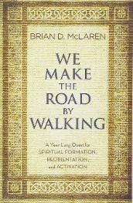
We Make the Road by Walking
Starting in September, Eastminster will embark on a year-long journey study of Brian McLaren's book "We Make the Road by Walking." Using this book in worship and small groups, we will read through the major stories of the Bible with a brief commentary that will help connect what we're reading with daily living. We will have a variety of small groups that will gather during the week or on Sundays to walk through the book together. You won't need to read the book ahead of time or commit to coming every week to participate. Keep looking here for the dates and times of small groups. Interested in coordinating a small group or hosting one at your house? Let Kristin know by calling the church or emailing revstroble@eastminsterchurch.org.

Worship Leader Training: August 27th, 6-7 pm
Each Sunday we have a worship leader who assists Kristin in leading the liturgy. At Eastminster this has traditionally been a currently serving elder. Starting in September we are opening up the opportunity for anyone in the congregation to assist. Come on August 27th to get a refresher on public speaking as well as learn about the liturgy that guides us each Sunday.

Eastminster Prayer Concerns
Please remember the following persons in your prayers:

Names to be included on the prayer list can be suggested to Rev. Stroble.
Eastminster Church Officers
Elders
Deacons

Eastminster Mission Statement
We, the members of Eastminster Presbyterian Church,
celebrate the grace of God and the redeeming love of Jesus Christ.
We believe we are called as God’s children to:
Praise and worship God;
Nurture and support spiritual growth as a family of faith;
Promote an open and welcoming community;
Reach out to the world with compassion;
and seek God’s justice.
We strive to develop and use our Spirit-given gifts
to share our faith in word and deed
as disciples who serve the Lord Jesus Christ
according to the will of God.

Adopted by the Session in 1999. Revised in 2011.

1315 Abbot Road, East Lansing, Michigan 48823
Phone: 517-337-0893
www.eastminsterchurch.org
Eastminster Prayer Concerns
Please remember the following persons in your prayers:

Becca Smith
Joe Walsh
Blakely Lindemuler

Names to be included on the prayer list can be suggested to Rev. Stroble.

1315 Abbot Road, East Lansing, Michigan 48823
Phone: 517-337-0893
www.eastminsterchurch.org
Eastminster Mission Statement
We, the members of Eastminster Presbyterian Church,
celebrate the grace of God and the redeeming love of Jesus Christ.
We believe we are called as God’s children to:
Praise and worship God;
Nurture and support spiritual growth as a family of faith;
Promote an open and welcoming community;
Reach out to the world with compassion;
and seek God’s justice.
We strive to develop and use our Spirit-given gifts
to share our faith in word and deed
as disciples who serve the Lord Jesus Christ
according to the will of God.

Adopted by the Session in 1999. Revised in 2011.

Eastminster Church Officers
Elders
Class of 2020 | Class of 2021 | Class of 2022
Robin Bell | Gary Blanchard | Steve Dickinson
Dave Duryea | Mary Lou Clifton | Mike Jones
Mike Foster | Mary Harvey | Estelle McGroarty
Neil Myer | Sam O’Neill | Susan Smalley
Pastor | Clerk of Session | Treasurer
Rev. Kristin Stroble | Susan Smalley | Robert Kleine
Deacons
Class of 2020 | Class of 2021 | Class of 2022
Barbara Dalzell  Heather Heitman  Cindy Mackay | Sherri Blanchard Linda Hardenbergh  Suzanne Hunt | Beverly Bonning  Sulin Campbell  Judy Dickinson

